# Netflix cost analytics

[Intro]

With the increasing usage of online streaming services such as Netflix, Amazon video and many other, not every country where these services are offered is treated the same way.

This article regards the analysis of the Netflix cost in different countries all around the world.  
The analysis takes in consideration the three major types of monthly subscriptions that Netflix offers to its customers and the number of articles (movies and Tv-Shows) offered in that area.

The analysis aims to find the best and worst countries to have Netflix via 2 different observations:

1. Netflix fee/titles ratio.
2. Netflix fee/gdp ratio.

The first analysis takes in consideration only Netflix parameters, not including financial aspects of the countries, such as gdp and gdp per capita.

The second analysis considers the gdp of the countries and offers a view on how to categorize Netflix services in that area (low, high, elite service).

All the analysis has been made using python, more precisely the modules Pandas, Numpy for numeric analysis, matplotlib and seaborn for visualization.

## Data set

The data on which the conclusions of this article are made relates to Netflix fees in the year 2021 and December 2021.[1]

### Data

The data used in this analysis is stored in a csv file; for this reason, it is not particularly difficult to translate it in a pandas data frame.

The original data source was composed by 65 rows and 7 columns, containing information regarding the fees and the number of articles offered in each country present in the data frame.

From left to right the columns were:

1. Total Library Size: total of articles (tv series and movies)
2. No. of TV Shows
3. No. of Movies:
4. Cost Per Month – Basic ($)
5. Cost Per Month -Standard ($)
6. Cost Per Month – Premium ($)

Netflix offers three types of subscription plan that differs in how many different devices can watch and download movies and TV shows simultaneously. See <https://help.netflix.com/it/node/24926> for more information.

### Revising the data

Because the columns name contains blank spaces and use a dot notation, they are not particularly efficient during the analysis in pandas. For this reason, a first step was to revise the data changing the columns name keeping the meaning but making them more efficient for direct access via pandas built-in functions.

This step was made by using the rename method of pandas

Figura 1-Changing columns name

In this format, the data frame columns are accessible using the dot format.

### Enriching the data: Average monthly subscription

Duo the fact that this analysis is focused on finding the best and worst places to have Netflix under a finance point of view, not considering aspects such as quality of the service and quality of the titles in the countries, the data frame needed to be enriched via introduction of derived data such as the average cost of a Netflix monthly subscription.

This info is easily calculated as the mean of the three Netflix fees regarding the basic, standard and premium subscription cost.

Using this information, it is possible to view which countries have the highest and lowest average cost for a Netflix subscription.

By a first analysis Netflix fees are different based on the economic situation of the countries in analysis.

### Lowest avg fees

Sorting the data frame in ascending order on the average Netflix fees we can find the following result:

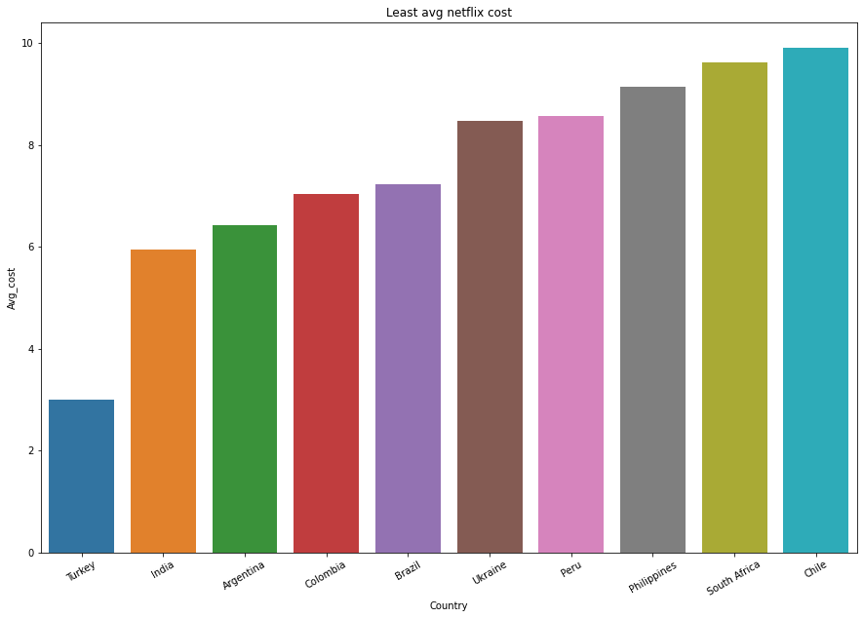

The least expensive fee offered by Netflix is Turkey ($3), followed by India ($6) and Argentina ($6.5).

This observation though does not consider factors such as GDP or number of titles offered in that country.

### Highest avg fees

Sorting in a decreasing order the data frame on the avg cost fee it is possible to find the countries where Netflix fees are more expensive.

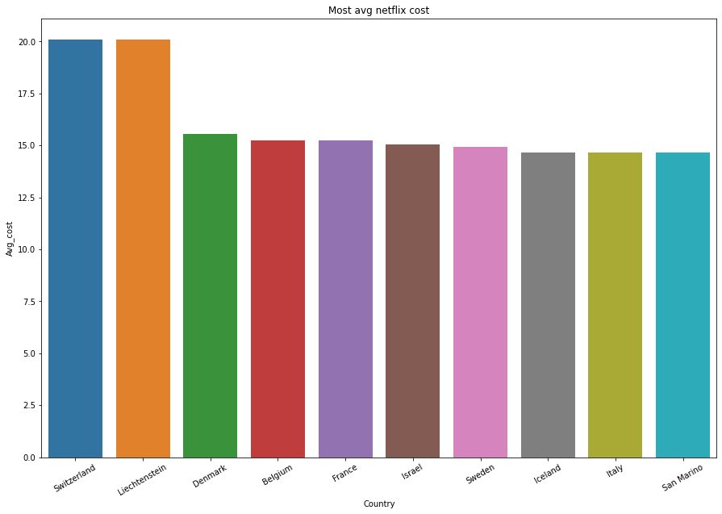

The highest average fees are in Switzerland and Liechtenstein which are both 20 dollars.

The other countries in the result have approximately the same average fee ($15).

It is supri

[other data used]

[questions on the data]

1. https://www.kaggle.com/prasertk/netflix-subscription-price-in-different-countries/version/2?select=netflix+price+in+different+countries.csv#